**Usage of the dig command.**

First on the terminal use the command

dig –h

In the similar way many of the given commands can be used. For eg, lets use authority now.

dig authority www.google.com. Write your notes below.

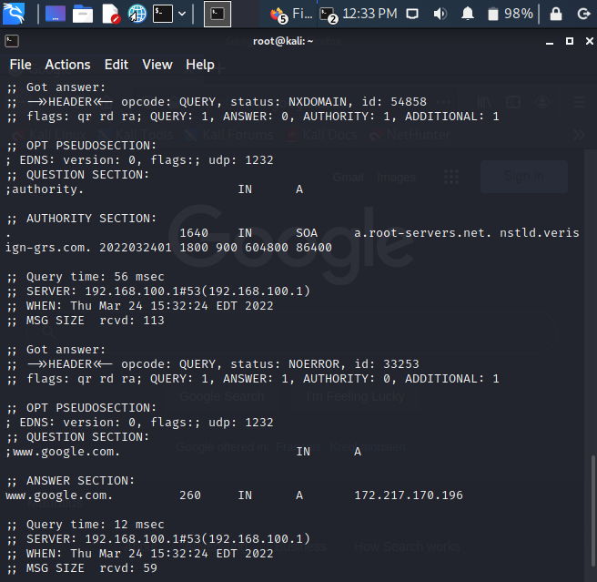

dig nssearch [www.facebook.com](http://www.facebook.com)

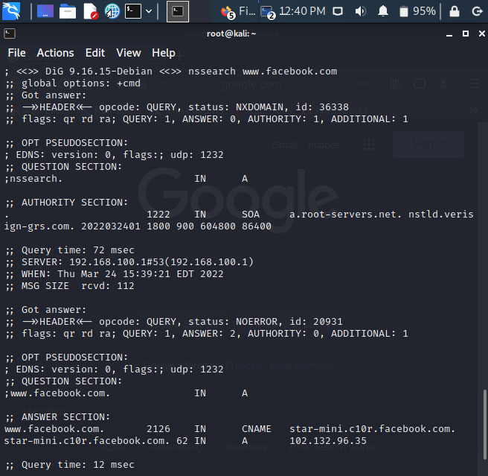

dig additional [www.facebook.com](http://www.facebook.com)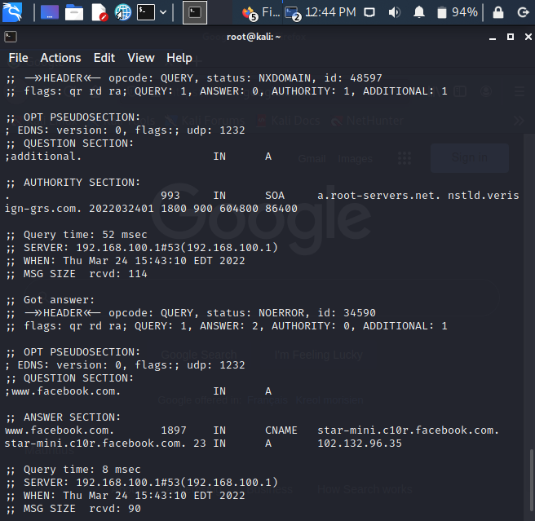

dig nsid www.facebook.com

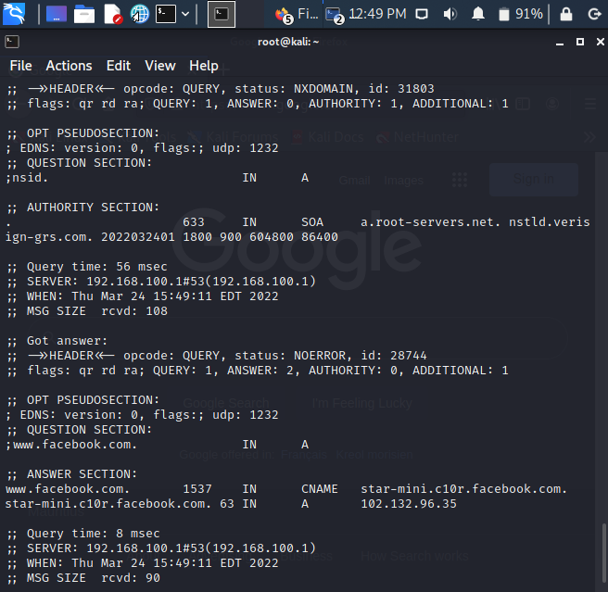

There are other options that can be used for several other purposes, feel free to explore them.

**Task 3 : Information Gathering command dnsenum**

Just like previous tools this is also used for the purpose of gathering information.

**Usage of the dnsenum command.**

dnsenum [options] [domain name]

Try the help to find all options, make notes of the one that seem interesting

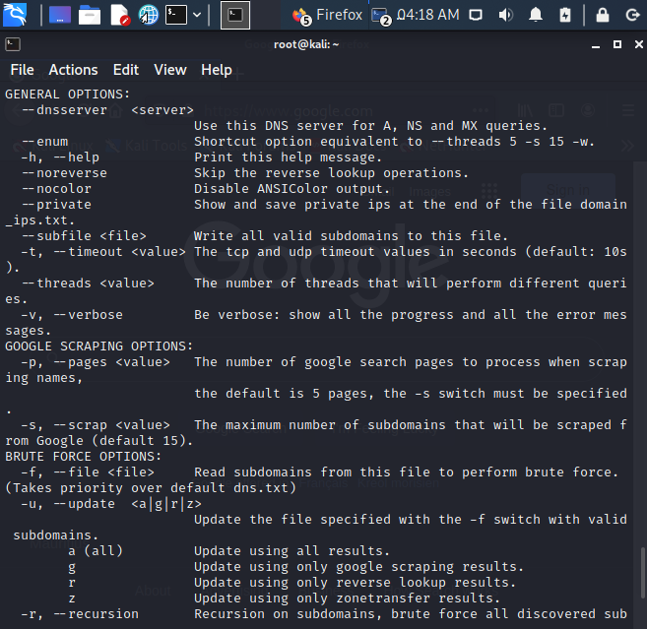

Try dnsenum –r www.google.com . write your notes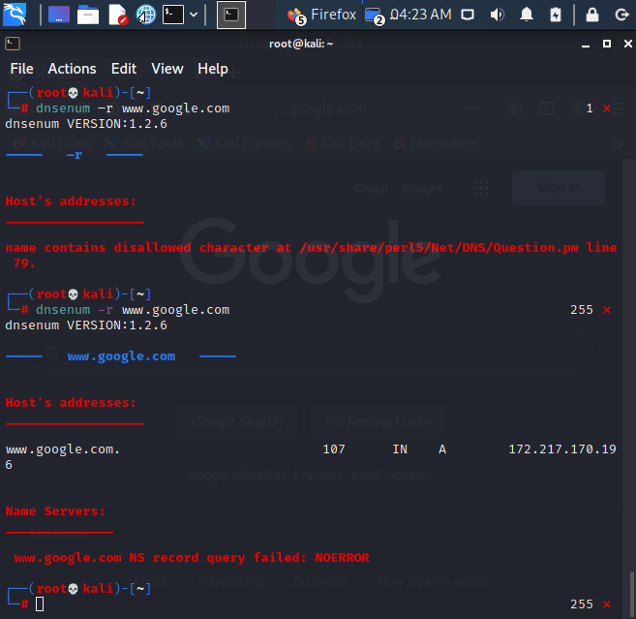

Task 4: Information gathering through Web mirroring:

1. Go to http://www.httrack.com

2. Download and install the version of httrack that suits your OS

3. After executing the software, the httrack window appears

4. Choose to create a new project

5. Enter a project name and category

6. Choose the Base path and press enter

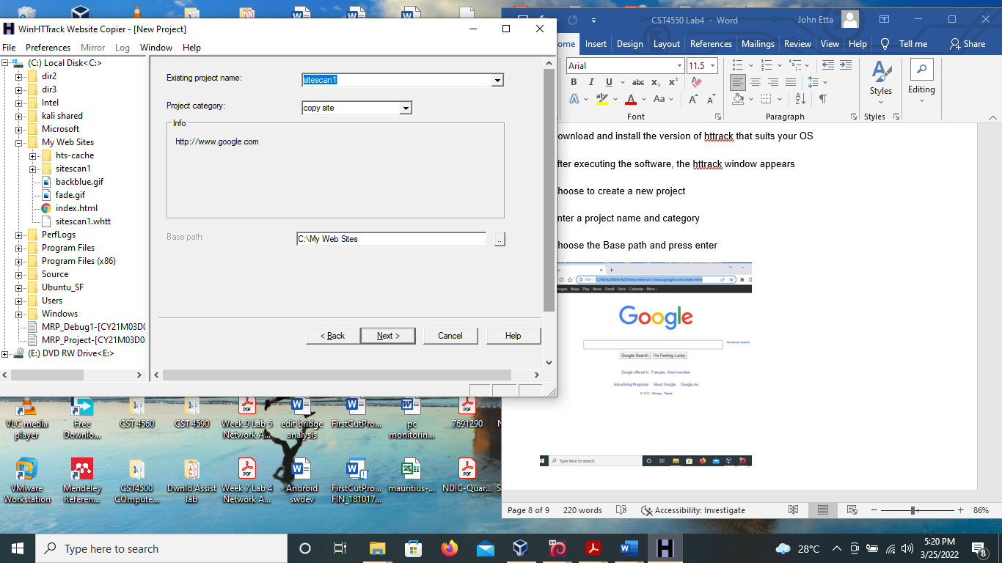

7. Import the URL you want to mirror and leave the other setting as default

8. Leave all the other settings as default and press finish, mirroring starts

9. On completion, browse the website, what do you notice?

10. Go to the base path and check the files.

